Crime in Haiti after the earthquake

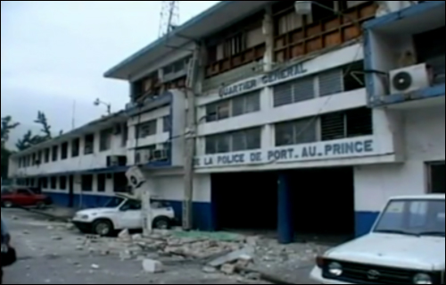

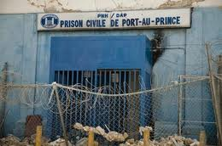
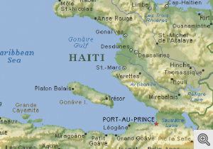

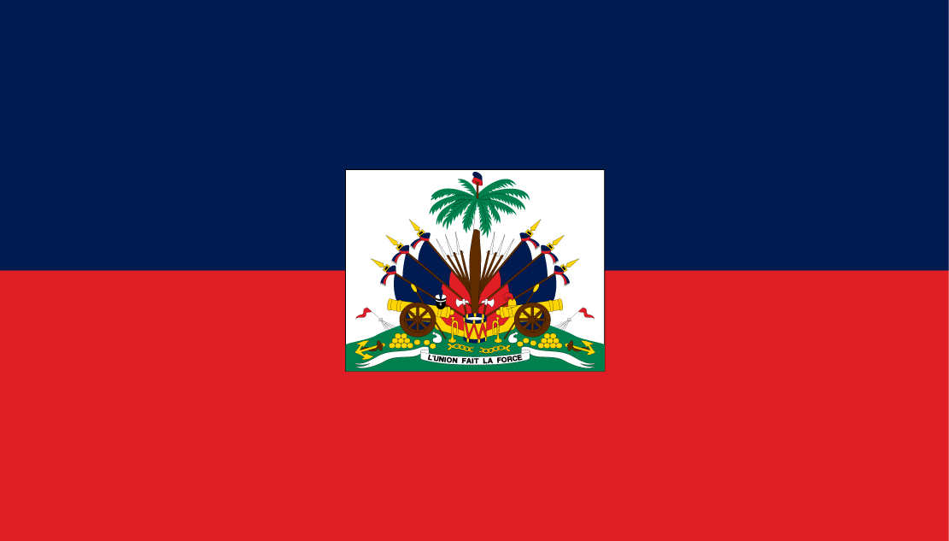

Crime in Haiti after the earthquake
Crime in Haiti has always been very high even before the Haiti earthquake. This is due to the illegal drug trade in Haiti. Kidnapping, death threats, murders, drug-related shootouts, armed robberies, home break-ins and car-jacking are common in Haiti. Generally, these crimes are committed by Haitians against other Haitians, although occasionally foreigners have been victimized. To make matters worse for locals Haiti has no military as the Haitian Armed Forces were demobilized in 1995. Other than the temporary United Nations Stabilization Mission in Haiti (MINUSTAH) force, the Haitian National Police (Police Nationale d'Haïti, PNH) is the only security force in the country following the disbandment of the Haitian military. The PNH has approximately 9,000 personnel. Specialized units are dedicated to crime response (SWAT), crowd control in Port-au-Prince and presidential security. With such a small security force it is easy for criminals to commit crimes and get away with it. After the 2010 earthquake crime rates rose dramatically due to over 5000 prisoners escaping from the main jail in Port au Prince.
Haiti National Police
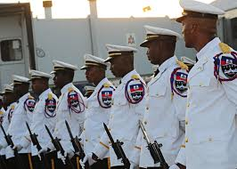
Haiti Swat Team
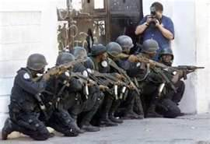

Crime in Haiti after the earthquake
More than 4,000 prisoners broke out of the central prison when the walls cracked and the prison guards fled to their homes to see if their families were alive. About 1,000 more fled from regional jails which suffered a similar fate.
International Response
The effort to recapture the prisoners has not gone very well so far due to no army in Haiti and the government are not putting much effort and money into recapturing the escaped convicts.
The UN decided to increase the number of troops it has in Haiti to 8940 and increase its police force to 4391 in an effort to help recapture the escape convicts. The USA sent in an extra 2200 troops and an extra 1800 sailors to increase its military presence to 16000.

